Acceptance tests   
“Acme Rookies v1.0”

|  |  |
| --- | --- |
| Development team | |
| **Identifier** | *G92* |
| **Members** | *Batista Núñez, Francisco.*  *de la Flor Bonilla, Álvaro.*  *Fernández Benjumea, Carmen.*  *Ferrete Molle, José Antonio.*  *Salvat Pérez, Antonio Manuel.*  *Sanchez Hipona, Antonio.* |
| **Testing team** | |
| **Identifier** |  |
| **Members** |  |
| **Indexing data** | |
| **Test designers** | *de la Flor Bonilla, Álvaro.*  *If you need to contact me:*  *alvarodelaflor@gmail.com*  *+34 665 381 121* |
| **Testers** |  |
| **Notes** | *Use cases of R17.1* |

**Table of contents**

Use case 17.1.1: Logged as auditor, create and edit a Curricula 3

Use case 17.1.2: Logged as rookie, delete the curricula and its components. 9

# Use case 17.1.1: Logged as auditor, create and edit a Curricula

Description

An user logged as Rookie must be able edit his curriculas, which includes creating, editing and deleting them. An audit can be updated or deleted as long as it’s saved in Draft Mode.

Access

First, the user must log as rookie in the login page. User: rookie, Password: rookie

The steps to follow are explained above.

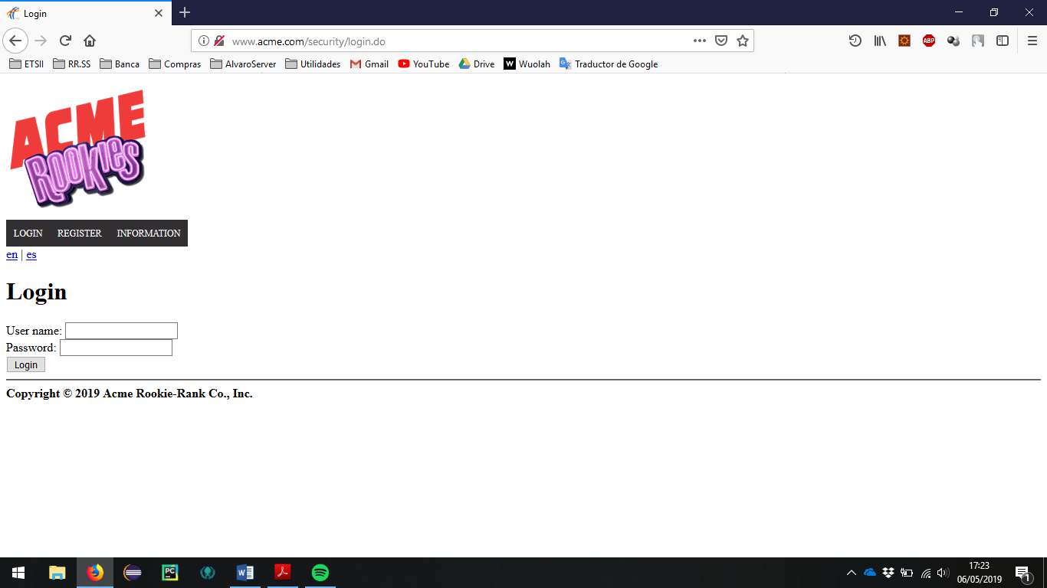

Go to the section of user profile.

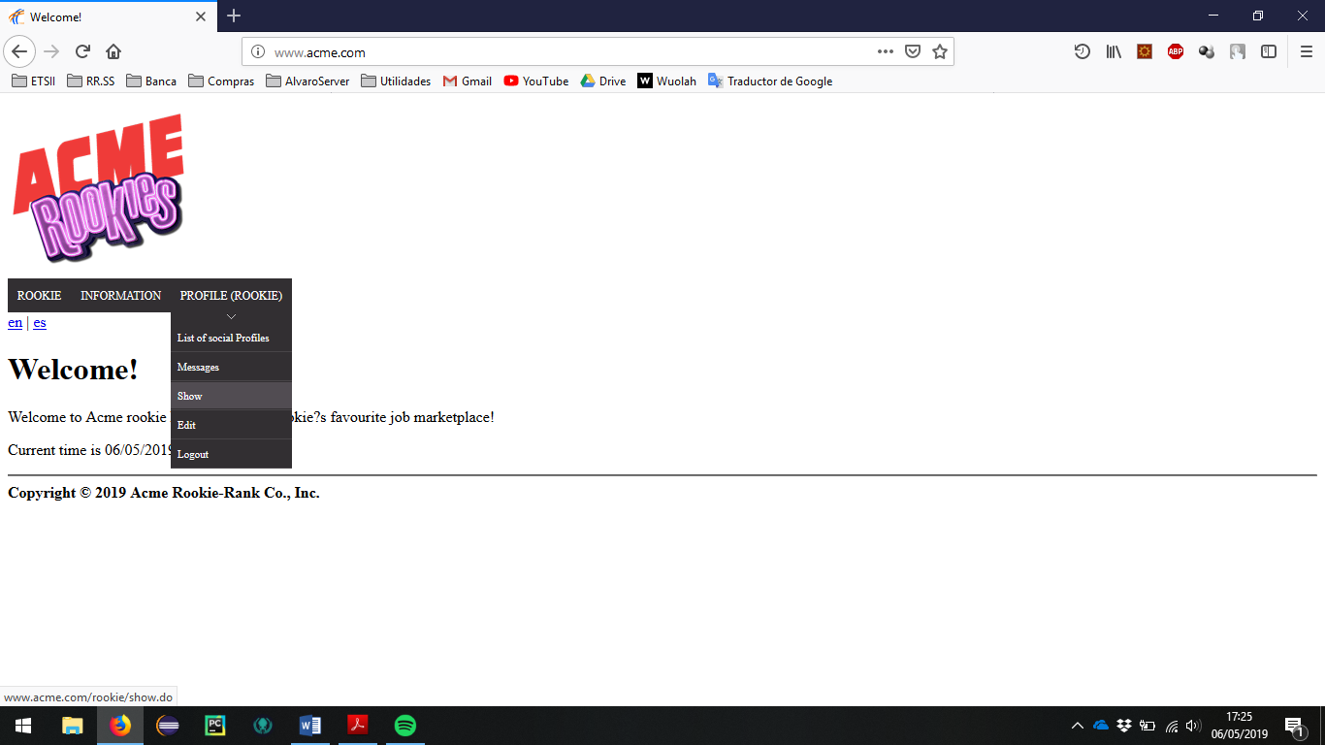

> Header Menu > Display the "PROFILE" options > Show

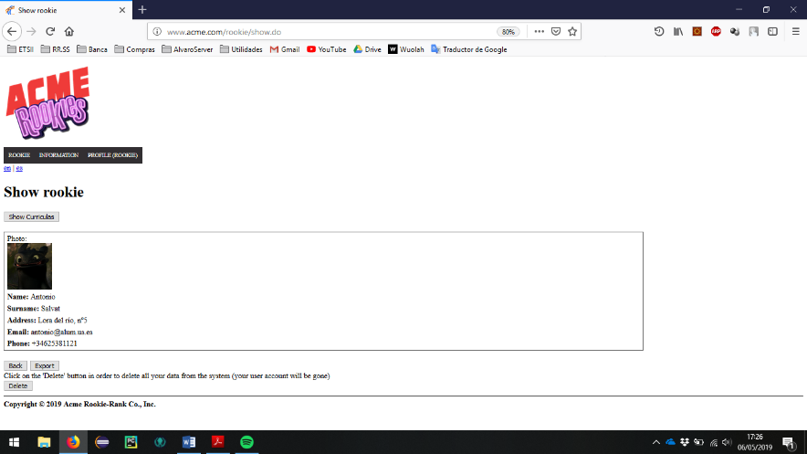The profile of the user with whom he is logged in should appear, next to a button in the header that redirects the list of his curricula.

The user must click on the button to show curriculas and later it will be shown, if the he use the rookie user with password rookie, a list with a single curricula as well as a button to create new curricula.

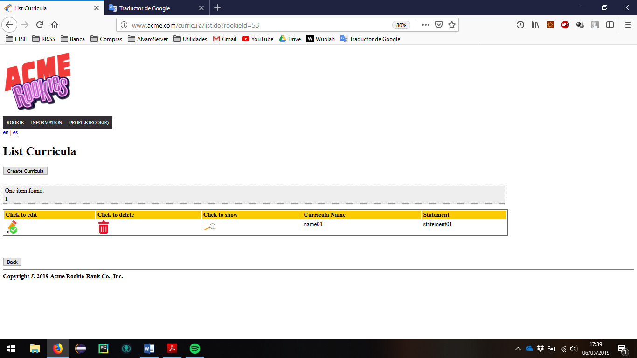

Tests

|  |  |
| --- | --- |
| Test 1 | |
| **Description** | Click on the button to create a new curriculum and fill it with invalid data. |
| **Expected** | In the first place a form with six fields must appear, being the first 5 of completeness mandatory.  After sending the form with erroneous fields, the error messages should appear right next to the field that they have completed in the wrong way and the curriculum should not be saved under any circumstances if an error is still present. |
| **Outcome** |  |
| **Notes** |  |

|  |  |
| --- | --- |
| Test 2 | |
| **Description** | Re-complete the previous form but with valid data. |
| **Expected** | If all the fields have been completed correctly the system will save the completed curriculum and redirect to the displayed view of the saved curriculum.  Make sure that all the fields are correct, see the change of the GitHub username by the link, the appearance of the buttons to edit and delete the created curricula, the buttons to create the position data and the educational data ... |
| **Outcome** |  |
| **Notes** |  |

|  |  |
| --- | --- |
| Test 3 | |
| **Description** | Correct listing. |
| **Expected** | Go back to the list of curricula and make sure that the new curriculum created now appears (press the back button). |
| **Outcome** |  |
| **Notes** |  |

|  |  |
| --- | --- |
| Test 4 | |
| **Description** | Add additional data to the curriculum. |
| **Expected** | Click on the magnifying glass and in the section to add additional information, attach new data.  The page should reload and the data should be added to a one-to-one list. An icon to delete must appear next to them.  Invalid data like a script should not be loaded. |
| **Outcome** |  |
| **Notes** |  |

|  |  |
| --- | --- |
| Test 5 | |
| **Description** | Click on the button to create a new position and fill it with invalid data. |
| **Expected** | In the first place a form with five fields must appear, being four completeness mandatory.  After sending the form with erroneous fields, the error messages should appear right next to the field that they have completed in the wrong way and the position should not be saved under any circumstances if an error is still present.  Make sure that the available position is valid (position belonging to an accepted application). |
| **Outcome** |  |
| **Notes** |  |

|  |  |
| --- | --- |
| Test 6 | |
| **Description** | Re-complete the previous form but with valid data. |
| **Expected** | If all the fields have been completed correctly the system will save the completed position data and redirect to the displayed view of the saved position data.  Make sure that all the fields are correct, see the change of the GitHub username by the link, the appearance of the buttons to edit and delete the created curricula, the buttons to create the position data and the educational data ...  The editing and deletion buttons must be present and functional. |
| **Outcome** |  |
| **Notes** |  |

|  |  |
| --- | --- |
| Test 7 | |
| **Description** | Check the creation and edited of educational data. |
| **Expected** | Repeat tests 5 and 6 for educational Data. |
| **Outcome** |  |
| **Notes** |  |

|  |  |
| --- | --- |
| Test 8 | |
| **Description** | Try to do GET hacking to the system (I). |
| **Expected** | Copy the edit URLs, and try to edit being a logged-in user (not the entity's creator) or a non-logged-in user.  You can use, as an example:  /curricula/rookie/edit.do?curriculaId=67  /positionData/rookie/edit.do?positionDataId=XXXXX  /educationalData/rookie/edit.do?educationalDataId=XXXXX  Being XXXXX and 67 the ID of the entity to edit.  The system must redirect to the start tab. |
| **Outcome** |  |
| **Notes** |  |

|  |  |
| --- | --- |
| Test 8 | |
| **Description** | Try to do GET hacking to the system (II). |
| **Expected** | Copy the list and show URLs being a logged-in user (not the entity's creator) or a non-logged-in user.  If you are not the creator of the entities or the owner of the list of curricula, no creation, editing or deletion button should appear.  You can use, as an example:  /curricula/show.do?curriculaId=67  /positionData/rookie/show.do?positionDataId=XXXXX  /educationalData/rookie/show.do?educationalDataId=XXXXX  Being XXXXX and 67 the ID of the entity to edit.  The system must redirect to the start tab. |
| **Outcome** |  |
| **Notes** |  |

# Use case 17.1.2: Logged as rookie, delete the curricula and its components.

Description

If the logged in user is the rookie creator of the curriculum he has the possibility of deleting the entire curriculum, or any of his attachments.

Access

First, the user must log as auditor in the login page. User: rookie, Password: rookie

Then follow the steps described above to get to the list of curricula.

Tests

|  |  |
| --- | --- |
| Test 1 | |
| **Description** | Delete a curricula |
| **Expected** | In the curricula list click on the red trash can icon, the selected curriculum should disappear from the list and from the system. |
| **Outcome** |  |
| **Notes** |  |

|  |  |
| --- | --- |
| Test 2 | |
| **Description** | Check the delete of educational data and position data. |
| **Expected** | Entities must disappear from their listings and from the system. |
| **Outcome** |  |
| **Notes** |  |

|  |  |
| --- | --- |
| Test 3 | |
| **Description** | Try to do GET hacking to the system. |
| **Expected** | Copy the delete URLs, and try to delete being a logged-in user (not the entity's creator) or a non-logged-in user.  You can use, as an example:  /curricula/rookie/edit.do?deleteId=67  /positionData/rookie/delete.do?positionDataId=XXXXX  /educationalData/rookie/delete.do?educationalDataId=XXXXX  Being XXXXX and 67 the ID of the entity to edit.  The system must redirect to the start tab. |
| **Outcome** |  |
| **Notes** |  |